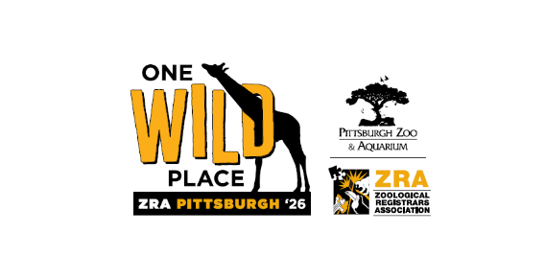

We’re counting down to the 2026 ZRA Annual Conference and we want to be sure you’re aware of the incredible value this week delivers. Whether you’re a long-standing member or new to ZRA, this conference is packed with professional development, networking opportunities, and memorable experiences you won’t want to miss.

So—should you attend?

Absolutely. And here’s why:

Friday, October 2, 2026

- Virtual Institute of Certified Records Managers (ICRM) Certified Records Analyst (CRA) Workshop
ZRA is excited to collaborate with the Institute of Certified Records Managers (ICRM) for the 18th consecutive year to provide information about ICRM certification and its relevance, value and benefits to those Records and Information Management (RIM) professionals working in the Zoological Registrar profession. Please join us for the ZRA- hosted virtual ICRM Certified Records Analyst (CRA) Workshop. ZRA will cover MEMBER attendance for the workshops as part of the FULL conference registration.

Sunday, 11 October 2026

- Pre Trip
Kick off the conference with a full-day trip to the National Aviary and the International Conservation Center. This immersive experience includes transportation, admission, and lunch, offering a unique look at conservation efforts and animal management outside the traditional conference setting. Keep in mind this is an additional cost outside the Full Registration fee.

Monday, 12 October 2026
- Applied Skills Workshops and Presentations
Open to all conference attendees, these hands-on sessions focused on practical tools, techniques, and real-world applications for zoo and aquarium registrars.

- ZIMS Workshop
Open to all conference attendees, this workshop is your opportunity to hear from experts, learn about recent updates, and ask questions.

- Tracks Workshop
Open to all conference attendees, this workshop is your opportunity to hear from experts, learn about recent updates, and ask questions.

- AnimalCare Software Workshop
Open to all conference attendees, this workshop is your opportunity to hear from experts, learn about recent updates, and ask questions.

- Registrar 101
Open to all conference attendees, this introductory session covers the fundamentals of zoo and aquarium records management—ideal for new registrars or those looking for a refresher.

- ZRA Committee Roundtable
Open to all conference attendees, have collaborative discussions with ZRA committees to share updates, exchange ideas, and provide feedback.
- Ice Breaker
Open to all conference attendees and guests. Kick off the 2026 ZRA Annual Conference with an unforgettable evening aboard the Gateway Clipper Fleet! Join fellow registrars for a relaxed and lively icebreaker cruise along Pittsburgh’s iconic rivers. Just a short walk from the Sheraton Pittsburgh Hotel at Station Square, you’ll board the Clipper and set sail past the city skyline, historic bridges, and vibrant riverfront. Included with Full Registration; otherwise, a fee applies.

Tuesday, 13 October 2026

- General Sessions
Open to all conference attendees; expect a day full of presentations on core categories of record keeping; wildlife permits and legislation; animal transport; records and collection management; and conservation.

- ZRA Member Flamingle
Open to all conference attendees and guests. Get ready to mingle and make new connections at our member Meet and Greet event. Included with Full Registration; otherwise, a fee applies.

- Silent Auction
Open to all conference attendees and guests; items will be available for viewing and bidding. Take a look at all the fun items donated by our colleagues and win the bidding war for your favorite items.

- Exhibitor Showcase
Open to all conference attendees and guests, connect with industry partners showcasing the latest tools, services, and innovations in zoo and aquarium records management—held alongside the Member Flamingle and Silent Auction.

Wednesday, 14 October 2026

- General Sessions
Open to all conference attendees; expect a day full of presentations on core categories of record keeping; wildlife permits and legislation; animal transport; records and collection management; and conservation.

- Optional Event
Open to all conference attendees and guests, unwind with an optional visit to the Duquesne Incline for scenic views of the city and a relaxed networking opportunity. Keep in mind this is an additional cost outside the Full Registration fee.

Thursday, 15 October 2026

- ZRA Committee Action Planning (Z-CAP) Workshop
This meeting is required for Committee Leadership but open to all ZRA members. We encourage all members to attend, especially NEW members, to learn about the Association's ongoing projects and committees. Expect to hear updates from the Board and each Committee. Attendees of this meeting will have the opportunity to participate in planning for next year. This is where you learn about the committees and what you might want to participate with as a member.

- Business Meeting
This meeting is open to ZRA Members only. All Members are encouraged to participate. We ask that all Professional Members make it a priority to attend the business meeting. Important decisions affecting all ZRA members are discussed and voted on (if necessary) at this time. Please note, only Professional Members can vote on ZRA business.

- Zoo Day
Open to all conference attendees and guests. Spend a full day immersed in wildlife, conservation, and connection at the Pittsburgh Zoo & Aquarium during one of the most anticipated experiences of the 2026 ZRA Annual Conference where you will be able to see their grounds, go behind-the-scenes and enjoy lunch and dinner at the zoo. Included with Full Registration; otherwise, a fee applies.

Friday, 16 October 2026

- Post Trip
Open to all conference attendees and any of their guests. Wrap up the week with a guided city experience featuring Phipps Conservatory and Botanical Gardens, a ride with Molly's Trolleys Pittsburgh, and time in the Strip District for shopping and local flavor. Transportation and admissions are included. Keep in mind this is an additional cost outside the Full Registration fee.

